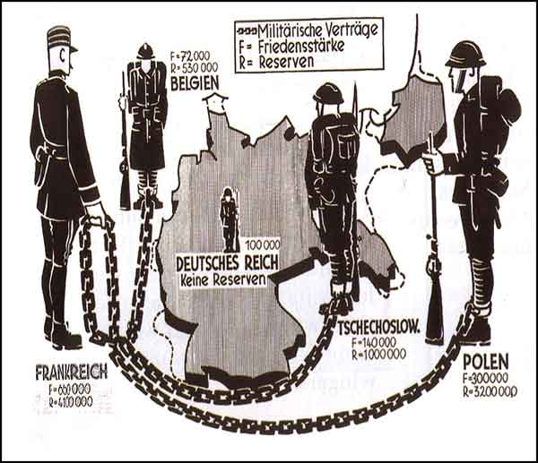
A cartoon from a German newspaper alongside a news story explaining the Treaty’s terms on Germany’s Army.

- Germany is in the middle, what impression do you get of Germany?
- Why are the other countries connected by chains?
- Who is holding the chains? Why?
- Why would a German make this cartoon, what does it show us about how they felt?

